SIMATS ENGINEERING (SAVEETHA SCHOOL OF ENGINEERING)
Department of Computer Science and Engineering

ASSESSMENT TOOL 2 – Industry Problem Solving Task

Course Code: | CSA06 | Course Title: | Design and Analysis of Algorithms
CO Assessed: | CO4: Articulation (BL4, BL5) | Assessment: | Assessment Tool 2 – Industry Problem Solving Task
Weightage: | 20% of CIA | Total Marks: | 100
CO4 Statement: | Solve optimization problems using dynamic programming and greedy strategies.
Student Name: | N.Thanveer basha | Reg. No.: | 192372358
Section / Batch: | CSE(Ai) | Date: | 20.08.2026

Instructions to Students
- Answer the following question. Total Marks: 100.
- Carefully analyze the given questions.
- Explain in detail with sample code if needed.
- Clearly identify all key issues.
- Provide a thorough analysis with validated results and performance evaluation.

Question Type | Focus Area | Questions
Industry Problem Solving Task | Focus on Solving optimization problems using dynamic programming and greedy strategies | Q1

SECTION A – Industry Problem Solving Task

Code of Conduct
I __N.Thanveer(192372122)_(Name / Reg No) certify that this submission is my original work and that I have adhered to the guidelines specified for this assessment. I understand that any violation of academic integrity rules will result in disciplinary action.
Signature of the Student: _N.thanveer________________________

RUBRICS FOR CALCULATION

Industry Problem Solving Task

Criteria | Weightage | Level 4 – Exemplary | Level 3 –  Proficient | Level 2 –  Developing | Level 1 –  Beginning
Understanding of  Industry Problem | 20% | Comprehensive understanding of  real-world problem and constraints | Good understanding with minor gaps in requirements | Basic understanding; some  requirements unclear | Poor understanding; misinterprets problem context
Application of  Engineering  Concepts | 25% | Applies advanced and relevant concepts  effectively to solve the problem | Applies appropriate  concepts with minor errors | Limited application of concepts | Incorrect or no application of concepts
Solution Design | 25% | Innovative, practical, and feasible solution  aligned with industry standards | Logical and feasible solution with minor gaps | Basic solution with limited feasibility | Unclear or impractical solution
Use of Tools | 15% | Effective use of modern tools,  technologies, and real  data | Appropriate use of tools with correct implementation | Limited or inconsistent use of tools | Minimal or incorrect use of tools
Analysis | 10% | Thorough analysis with validated results and performance evaluation | Good analysis with reasonable validation | Basic analysis with limited validation | Poor or no analysis
Professionalism | 5% | Highly professional, well-documented,  and clearly presented  work | Good documentation and presentation | Basic documentation with some gaps | Poor documentation and presentation

Marks Evaluation:
Criteria | Wt. | Level 4 –  Exemplary | Level 3 –  Proficient | Level 2 –  Developing | Level 1 –  Beginning
Understanding of Industry Problem | 20%
Application of Engineering Concepts | 25%
Solution Design | 25%
Use of Tools | 15%
Analysis | 10%
Professionalism | 5%
Total Marks (100):

Faculty In-charge | Course Coordinator | Head of Department
Name: | Name: | Name:
Signature: _______________ | Signature: _______________ | Signature: _______________
Date: ___________________ | Date: ___________________ | Date: ___________________

QUESTION AND SOLUTION :-

E-COMMERECE RECOMMENDATION SYSTEM

An online platform must recommend products to users based on browsing history and similarity patterns. Analyze how graph-based algorithms can be used to model user-product relationships. Identify constraints such as large-scale data and dynamic updates. Design a solution using ranking algorithms and similarity measures. Discuss implementation using scalable tools. Evaluate algorithm performance and efficiency. Interpret the impact on user engagement and business growth.

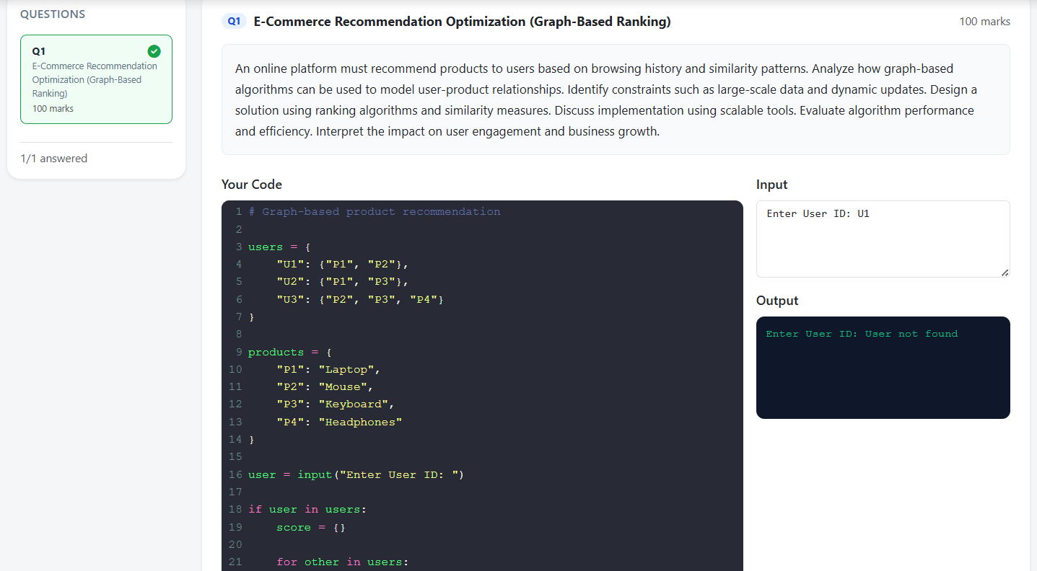

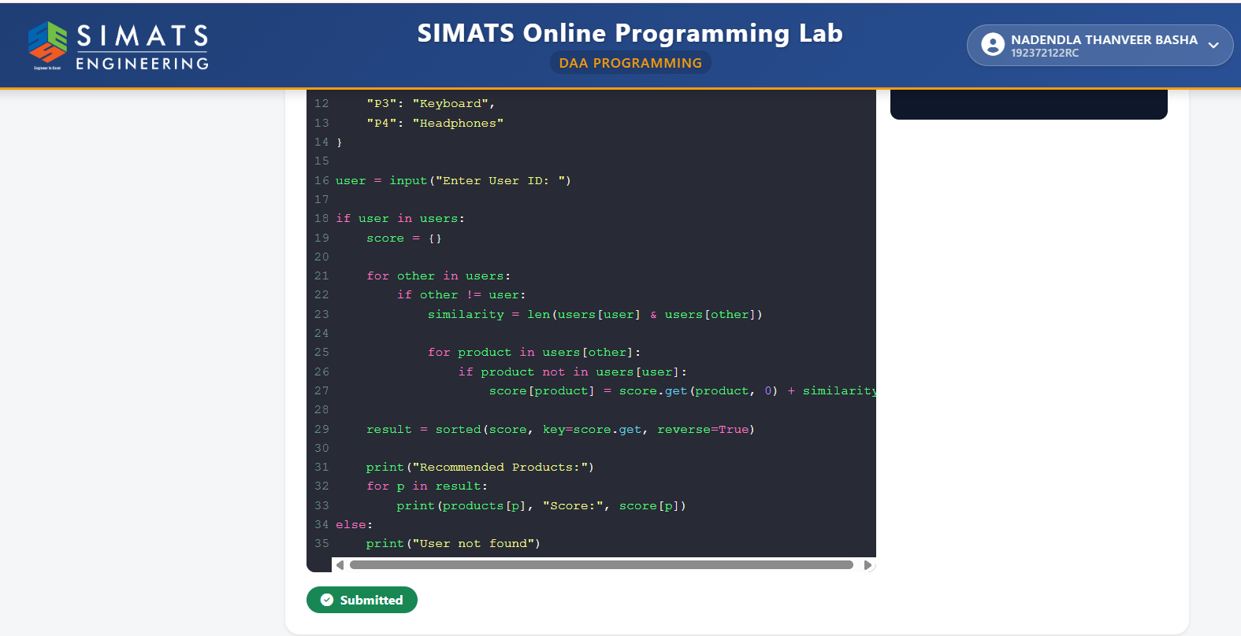

An E-Commerce Recommendation System is an intelligent software system that suggests products to users based on their interests, browsing history, purchasing behavior, ratings, and similarities with other users or products. Recommendation systems are widely used in online shopping platforms because the number of available products can be extremely large. Without recommendations, users may find it difficult to discover products that are relevant to their requirements.

The proposed system uses graph-based algorithms to model relationships between users and products. In this approach, users and products are represented as nodes, while interactions such as browsing, clicking, purchasing, rating, or adding products to a cart are represented as edges. By analyzing these relationships, the system can identify similar users, related products, and potential products that a particular user may be interested in.

The recommendation engine combines graph relationships, similarity measures, and ranking algorithms to generate a personalized list of products. The system must also handle large-scale data, frequent user interactions, continuously changing product information, and real-time updates.

-------------------------------

